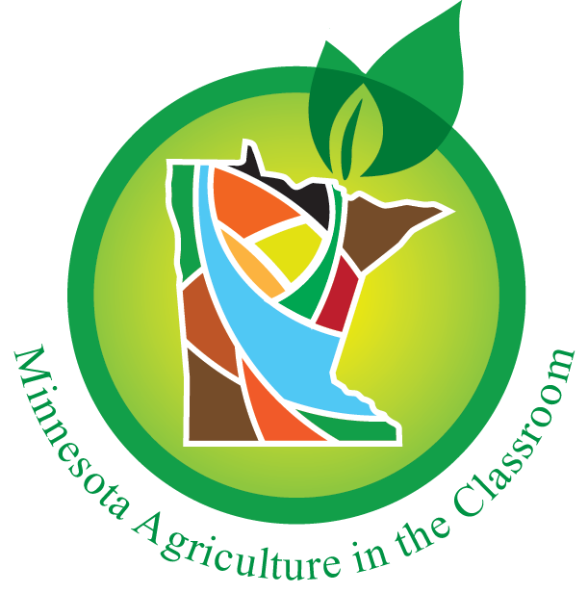
FOR IMMEDIATE RELEASE

Erica Sawatzke
Board Chair
Minnesota Agriculture in the Classroom Foundation
320-808-9477
ericanelson9477@gmail.com

November 22, 2019

[Minnesota] -- Minnesota Agriculture in the Classroom Board Chair, Erica Sawatzke, announces, “Today Minnesota Agriculture in the Classroom begins a new chapter and is proud to announce the hiring of a new Executive Director. Ann Marie Ward will take on the role of the MAITC Foundation Executive Director.”

Ms. Ward is from the Bemidji area and previously served as a Youth Development 4-H Program Coordinator. Her previous work in education and PBS gives her a great platform for moving the MAITC Foundation forward. Ms. Ward also holds a Bachelor of Science in Mass Communications and a minor in Business Administration.

Ms. Ward shares, “This opportunity to lead and continue the growth of MAITC, working with a team of amazing staff that are truly powered by passion, will be most rewarding. I am excited to work with supporters, grow new partnerships and pursue the Vision: Ag is valued by all.”

Ms. Ward comes to the organization as the previous executive director, Joel Mathiowetz, steps back from the organization. Mr. Mathiowetz shares, “These past six years have been a blast and I’m humbled and honored to have served as the MAITC Executive Director. I’m excited for the next chapter of MAITC with a great team of passionate individuals continuing the great work of Ag Literacy.”

About Minnesota Agriculture in the Classroom
Minnesota Ag In the Classroom provides free curriculum, educational resources, grants, outreach and professional development opportunities to train the trainers (educators and ag advocates) in Minnesota to increase ag literacy through K-12 education.

For decades, the public and private sectors have pooled human and financial resources to advance agricultural literacy among K-12 students and educators through the Minnesota Agriculture in the Classroom (MAITC) Program. This unique partnership model provides program consistency and credibility in Minnesota's agricultural and educational communities and is known for effectively leveraging resources from both sectors.

Learn more about Minnesota Agriculture in the Classroom and the free resources it offers on mn.agclassroom.org.
###

Video:
Joel Mathiowetz Welcomes Ann Marie Ward to Minnesota Agriculture in the Classroom
https://youtu.be/Omhr82rBC44

